**Software Testing Assignment**

**Module–1(Fundamental)**

* What is SDLC

1. SDLC means Software development life cycle which is a structure imposed on the development of software product. It defines the procees for planning, ananlysis, design, implementing, testing, maintenance and support. There are many different models in SDLC, which runs the process by step by steps or different phases. The methodology of SDLC process can be different in all the companies and industries. SDLC phases include Requirement Gathering, Analysis, Design, Implementation, Testing, Maintenance.

* What is software testing?

1. Software testing is a process of identifying the correctness, completeness, and quality of a developed software. It is a process of evaluating the system or its components to find whether it satisfy the desire requirement or not. Software testing is executing a system to find any gaps, errors or missing requirement in contrary to the expected requirements.

* What is agile methodology?

1. Agile model is a SDLC model which is a combination of iterative and incremental process model. It focus on the the adaptability and customer satisfaction by delivering the working software product. It works by breaking the procees into small builds and this builds are provided in iterations. Each iteration lasts for about 1 to 3 weeks. Every iteration involve cross functional teams working simultaneously on various areas like planning, requirements, analysis, design, coding, unit testing and acceptance testing.

* What is SRS

1. SRS is software requirement specification, it is a complete description of the behaviour of the system to be developed. It includes the set of use cases that describe all interaction that the user will have with the software.

* What is oops

1. Object oriented programming system: black box testing, functional testing.

Identify the objects and assign the responsibilities to the object. Object can communicate with other object by sending message. Object is like a black box, the internal data is hidden.

* Write Basic Concepts of oops

Object

Class

Inheritance

Abstraction

Polymorphism

Encpsulation

* What is object

1. Instances of a class. To create a memory of a class. To access the whole property of a class except private.

* What is class

1. A collection of a data member and member function with its behaviour. Class can be considered as the blueprint of object.

* What is encapsulation

1. Wrapping up of data into a single unit, private the data member or member function. Encapsulation is placing the data and relevant functions that work.

* What is inheritance

1. Properties of a parent class extend into child class. Inheritance describes the relationship between two class. Main purpose is reusability, extendibility.

There are mainly 5 types: Single, Multilevel, Heirarchical, multiple(Java does not support), Hybrid(Java does not support).

* What is polymorphism

A) Ability to take one name having different forms, many forms or multiple forms. It allows different objects to respond to the same message in different ways.

There are two types: Compile time(Method overloading) Runtime(Method overrading)

* Draw Usecase on Online book shopping

A)

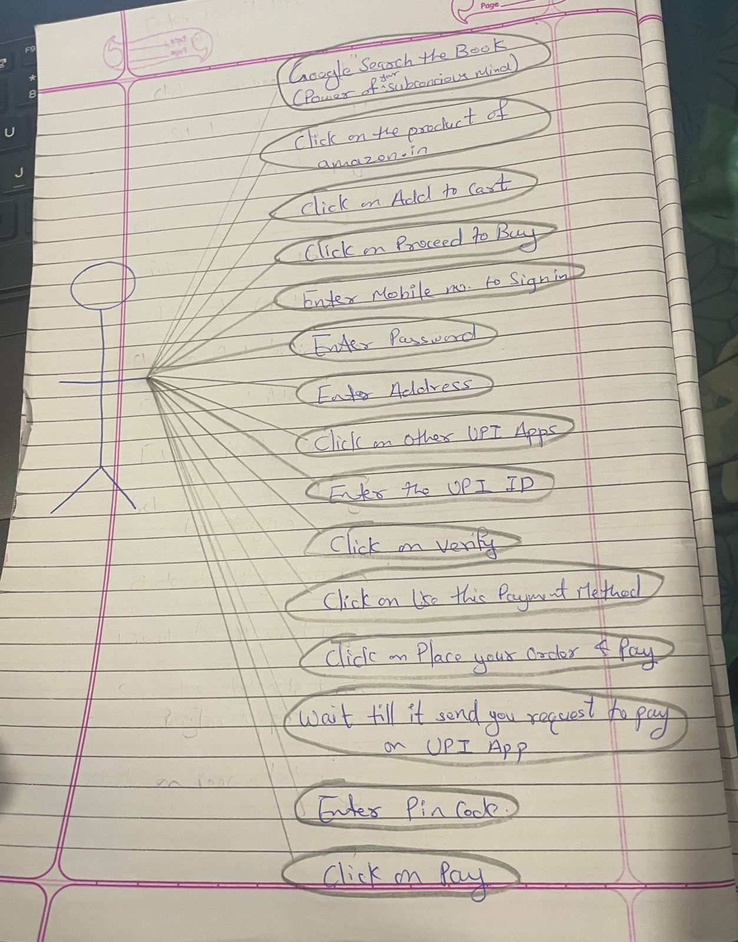

* Draw Usecase on online bill payment system (paytm)



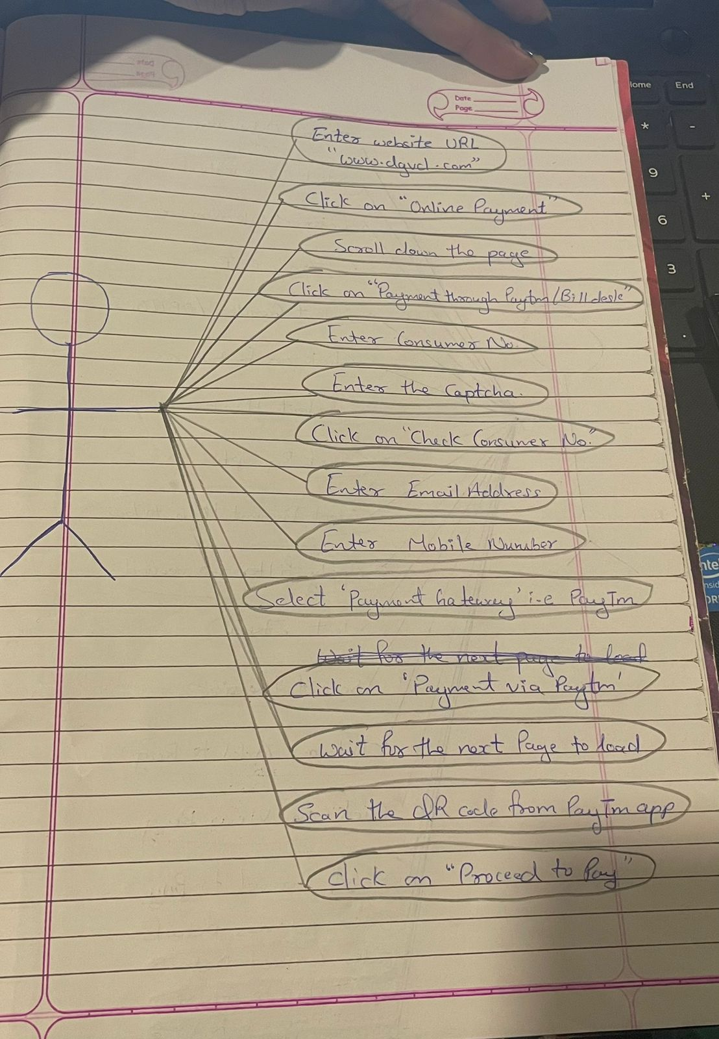

* Write SDLC phases with basic introduction

1. **Requirement** gathering: Customer needs/Requirement

**Analysis**: Represent the “What” phase, what is to be built. This phase defines the requirement of the system.

**Design**: It designs the architecture document of the process. Test plan

**Implementation**: The team build exactly what has been requested and construct the solution in software.

**Testing**: Testing the quality of the software & validate the solution.

**Maintenance**: Changing the process after deployed. Repair defects.

* Explain Phases of the waterfall model

1. Requirement

Analysis

Design

Implementation

Testing

Maintenance

* Write phases of spiral model

1. Planning

Risk Analysis

Engineering

Customer Evaluation

* Write agile manifesto principles

1. Individaul Interaction

Working Software

Customer collaboration

Responding to change

* Explain working methodology of agile model and also write pros and cons.

1. Agile model believes that every project needs to be handled differently and tailored to best suit the project requirements. In agile the tasks are divided into small time frames to deliver specific feature for a release.

**PROS:** Promotes teamwork and cross training

Very realistic approach to software development

Resource requirements are minimum

Easy to mange

Give flexibility to developers

Minimal rules and documentation easily employed

**CONS:** Agile leader or agile PM practice is must.

Heavily depends on customer interaction, if customer is not clear than the team can be driven to the wrong direction.

More risk of sustainability, maintainability & extensibility.

Deliver management is strict.

* Draw usecase on Online shopping product using COD.

A)

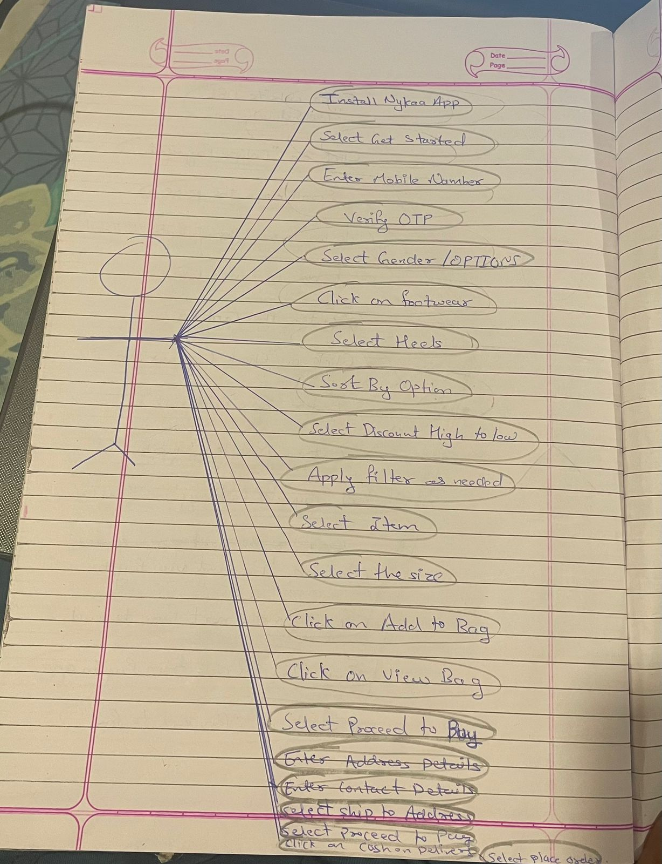

* Draw usecase on Online shopping product using payment gateway.

A)

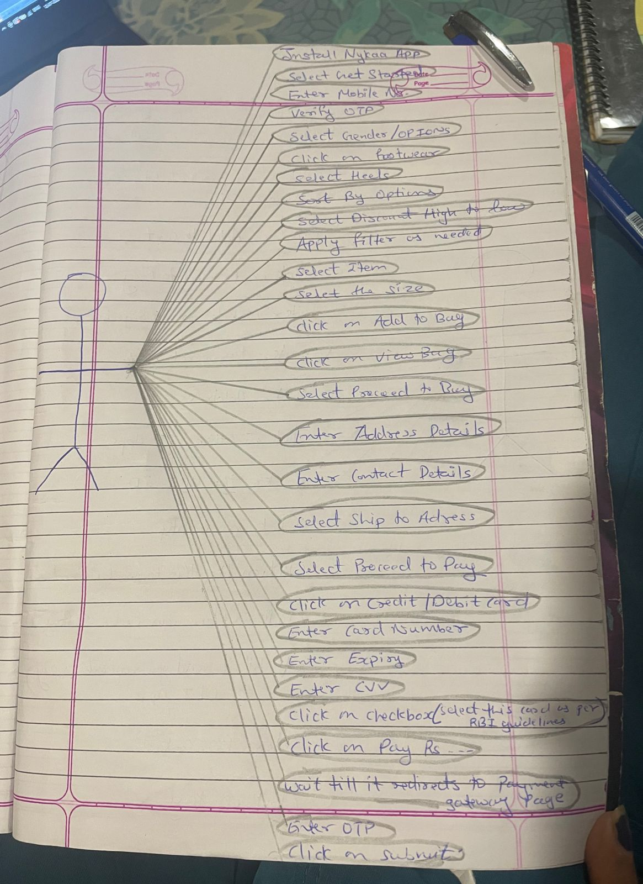

**Module–2(Manual Testing) & Module–4**

* What is Exploratory Testing?

1. Exploratory testing is a concurrent process where test design, execution and logging happen simultaneously. The focus of exploratory testing is more on testing as a “thinking activity”.

* What is traceability matrix?

1. To protect against the changes you should be able to trace back from every system component to the original requirements that caused its presence.

* What is Boundary value testing?

A)Boundary value analysis is a methodology for designing test cases that concentrates software testing effort on cases near the limits of valid range.

* What is Equivalence partitioning testing?

A)Equivalence partitioning testing aim is to treat groups of inputs as equivalent and to select one representative input to test them all. Equivalence partitioning can be used for all levels of testing. Reviewing the documents such as the Functional Design specification and detailed design specification and also identifying each input condition with in the function.

* What is Integration testing?

A)Testing performed to expose the defects in the interfaces and in the interactions between integrated components or system. It is a level of software testing process where individual units are conbined and tested ad a group.

* What determines the level of risk?

A)A factor that could result in future negative consequences, usually expressed as impact and likelihood.

* What is Alpha testing?

A)Alpha testing is always performed by developers at software development site. Sometime it is also performed by independent testing team. Alpha testing is not open for market and public, it is conducted for software application and project. It is always performed in virtual environment.

* What is beta testing?
* It is also known as field testing. It is always perfomed by the customer at their site. It is not performed by individual testing team. Beta testing is always open to market and public. It is perfomed in real time environment and conducted for software product.
* What is component testing?

A)It is also known as Unit testing. A minimal software item which is tested in isolation is component testing. Unit testing is the first level of testing process and is performed before the integration testing.

* What is functional system testing?

A)Functional system testing is a requirement that specifies a function that a system or system component should perform.

* What is Non-Functional Testing?

A)Testing of attribute of the componentor system which do not relate to functionality, eg. Reliable, efficiency, usability, interoperability, maintainability. It test to how the system will work.

* What is GUI Testing?

A)Graphic User Interface testing is the process of testing the system’s GUI under the Test. GUI testing involves checking the screens with the controls like menu, buttons, icons, toolbar, menubar, dialogue boxes etc.

* What is Adhoc testing?

A)Adhoc testing is an informal type of testing with an aim to break the system. It does not follow any test design techniques to create test cases. Testers randomly test the application without any test cases or any business requirement document.

* What is load testing?

A)It’s a performance testing to check system behaviour under load. Testing an application under heavy loads, such as testing of a website under arrange of loads to determine at what point the system response time fail.

* What is stress Testing?

A)System is stressed beyond its specifications to check how and when it fails. Performed under heavy load like putting large number beyond storage capacity, complex queries, continuous input to system or database load.

* What is white box testing and list the types of white box testing?

A)White box testing is based on an analysis of the internal structure of the component or system.

Types of white box testing:

Unit testing, Security testing, Conditional testing, Integration testing, Performance testing.

* What is black box testing? What are the different black box testing techniques?

A)Black box testing is either functional or non-functional, without reference to the internal structure of the component or system.

Black box testing techniques: Equivalence partitioning, Boundary value analysis, Decision table, State transition test.

* Mention what are the categories of defects?

A)Database defects: Deals with improper handling of database. Critical functionality defects: Crucial functionality of the application get hampered by these type of bug occurrence. Functionality defects: This defect affect the functionality of application. User Interface defects:The bugs deals with problem related UI. Security defects: Improper handling of data sent from user to application, this defect are most severe and given highest priority.

* Mention what bigbang testing is?

A)In big bang testing all the components/modules are integrated simultaneously, after which everything is tested as a whole.

* What is the purpose of exit criteria?

A)The purpose of exit criteria is to define when we STOP testing either at the End of the testing(product go live) or at the End of the phase of testing(hand over from system test to UAT)

* When should "Regression Testing" be performed?

A)Regression testing is testing the previously tested program following modification to ensure that defects have not been introduced in unchanged area of software. It is performed when the software or its environment is changed.

* What is 7 key principles? Explain in detail?

A)**Testing shows presence of defects**: Testing shows the defects which are present but cannot prove that there are no defects in the system.

**Exuastive testing is impossible:** Testing everything including all inputs and preconditions is not possible. So, instead of exhaustive testing we can approach the testing on the basis of priority and severity.

**Early Testing:** Testing activities should start as early as possible in the software development life cycle, and should be focused on defined objectives.

**Defect Clustering:** Small numbers of modules having the most defects discovered during pre-release of testing and are responsible for most of the failures.

**Pesticide Paradox:** If the same tests are repeated over and over again eventually there will be no defects found in the same sets of test cases, so in this situation pesticide paradox is used. The test cases need to be reviewed and revised and new tests need to be written to test different part of the software.

**Testing is context dependant:** Testing is done differently in different context. Every different site have a different perspective of testing.

**Absence of error fallacy:** If the system is built unusable and it does not meet the customer’s requirement then finding and fixing defects does not help.

* Difference between QA v/s QC v/s Tester

A)

|  |  |  |
| --- | --- | --- |
| **QA** | **QC** | **Tester** |
| Activities that ensure the implementation of the process/procedures with respect to verification of developed software and expected requirements. | Activities that ensure that the verification of the developed software with respect to documented requirement. | Activities that ensure the identification of the defects/bugs in the software. |
| Focuses on processes and procedures. | Focuses on acual testing with intend to identify bugs. | Focus on actual testing. |
| Preventive activities | Corrective process | Preventive activity |
| Process oriented | Product oriented | Product oriented |
| Subset of STLC | It is considered as a subset of QA | Subset of Quality control |

* Difference between Smoke and Sanity?

A)

|  |  |
| --- | --- |
| **Smoke** | **Sanity** |
| Smoke testing is performed after software build to ascertain that tha critical functionalities of the program works fine. | Sanity testing is performed to ascertain that the bug have been fixed and no further issue are generated due to the changes. |
| This testing is performed by the developers | This testing is performed by the testers |
| This testing is usually documented or scripted | This testing is usually not documented |
| Smoke testing perfomed on the entire system from end to end | Sanity testing is performed only on the component of entire system |
| Smoke testing is like checking the whole diamond necklace | Sanity testing is like checking the diamond individually |

* Difference between verification and Validation

A)

|  |  |
| --- | --- |
| **Verification** | **Validation** |
| Process of evaluating work products of development phase to determine whether it meets the requirements of that phase | Process of evaluating software during or at the end of the development process to determine whether it meets the specific businessrequirements |
| Reviews, Inspection, Walkthrough | Testing |
| White box testing or static testing | Black box testing or dynamic testing |
| Building the product right(Process) | Building the right product(Product) |
| Plan, Requirement specs, Design, Spec, Code | The actual product |

* Explain types of Performance testing.

A)

* What is Error, Defect, Bug and failure?

A)A mistake in the coding is called error, an error which is found by the tester is called Defect, a defect accepted by Developer is Bug, build which do not meets the specified requirements is Failure.

* Difference between Priority and Severity

A)

|  |  |
| --- | --- |
| **Priority** | **Severity** |
| It shows the level of importance | It denotes the degree of impact |
| Priority types consist of Low, Medium and Critical | Severity types consist of Critical, Major, Moderate, Minor, Cosmetic |
| Priority is relative and business focused | Severity is absolute and customer focused |

* What is Bug Life Cycle?

A)The duration or time span between the first time defects is found and the time that it is closed successfully, rejected, postponed or deferred is called as ‘Bug life cycle’.

NEW

Assigned

Duplicate

Rejected

Deffered

Not a Bug

Open

Fixed

Pending Retest

Reopened

Retest

Verified

Closed

* Explain the difference between Functional testing and Non Functional testing

A)

|  |  |
| --- | --- |
| **Functional Testing** | **Non Functional Testing** |
| Testing based on an analysis of the specification of the functionality of a component or system | Testing of attribute of the componentor system which do not relate to functionality. |
| Verifies the functionality of the software | Verifies the performanceof the software |
| Performed first | Performed after functional testing |
| Describe what product does | Describe how product does |
| Unit testing, Integration testing, UAT testing are some types | Performance testing, Load testing and stress testing are some types |

* To create HLR & TestCase of 1)(Instagram , Facebook) only first page

A) File uploaded on github- HLR & Testcase of Instagram

2) Facebook Login Page : https://www.facebook.com/

A) File uploaded on github- HLR & Testcase of facebook

* What is the difference between the STLC (Software Testing Life Cycle) and SDLC (Software Development Life Cycle)?

A)

|  |  |
| --- | --- |
| **STLC** | **SDLC** |
| STLC is a systematic approach to testing a software application to ensure that it meets the requirements and is free of defects. | SDLC is a structure imposed on the development of a software product that defines the process for planning, implementation, testing, documentation, deployement and ongoing maintenance and support. |
| Software testing life cycle | Software development life cycle |
| Related to software testing | Primarily concerned with software developement |
| STLC phases consist of Requirement analysis, Test planning, Test case development, Test environment setup, Test execution, Test cycle closure. | SDLC phases consist of Requirement Gathering, Analysis, Design, Implementation, Testing, Maintenance. |
| In STLC QA team analysis all the requirement from the requirement document | In SDLC business analyst gather all project related requirements from a stakeholder |
|  |  |

* What is the difference between test scenarios, test cases, and test script?

A)

|  |  |  |
| --- | --- | --- |
| **Test Scenarios** | **Test Case** | **Test Script** |
| Test scenario is any functionality that can be tested. | Test cases involves the set of steps, conditions and inputs which can be used while performing the test tasks. | A set of sequential instruction that detail how to execute a core business function. |
| Test scenarios is ‘What to be tested?’ | Test case is ‘How to be tested?’ |  |
| Test scenarios are derived from the use cases. | Test cases are derived from test scenario. |  |
| Test scenario represents a series of actions that are associated together | Test case represents a single action by the user. |  |
|  |  |  |

* Explain what Test Plan is? What is the information that should be covered.

A)A document describing the scope, approach, resources and schedule of intended activities. Informtion which is covered is defining the overall approach of testing, including the definition of test levels, entry and exit criteria. It also cover test planning, test planning stratergy, test planning activity, test planning factor, and exit criteria.

* What is priority?

A)Priority is Relative and business-focused. Priority defines the order in which we should resolve the defects. This priority is mentioned by the tester to the developer mentioning the time frame to fix the defects. For eg: If a customer have added 2-3 items in a cart after checkout it only shows the total amount to pay to customer and do not show the bifurcation of the amount like how much GST is deducted, Convenience charges, Item price this all are not shown then it is high priority to solve.

* What is severity?

A)Severity is absolute and customer-focused. It defines the impact that a given defect has on the system. It mention that how the defect can affect the software. For eg: If in a website the cart icon do not show clickable but will open the cart after clicking on it, so few customers might not know that it can be clicked as the clickable logo/sumbol not be seen on the cart icon.

* Bug categories are…

A) Database defects, Critical functionality defects, Functionality defects, User Interface defects, Security defects.

* Advantage of Bugzila .

A)Advanced search capabilities, Email Notifications, Modify/file Bugs by email, Time tracking, Strong security, Customization Localization.

* Difference between priority and severity

A)

|  |  |
| --- | --- |
| **Priority** | **Severity** |
| It shows the level of importance | It denotes the degree of impact |
| Priority types consist of Low, Medium and Critical | Severity types consist of Critical, Major, Moderate, Minor, Cosmetic |
| Priority is relative and business focused | Severity is absolute and customer focused |

* What are the different Methodologies in Agile Development Model?

A) Agile methodology is a way to manage a project by breaking it into several phases. It involves constant collaboration with stakeholders and continuous improvement at every stage. Once the work begins, team cycle through a process of planning, executing, and evaluating.

* Explain the difference between Authorization and Authentication in Web testing.What are the common problems faced in Web testing?

A) Authentication is knowing the identity of the user. For eg, User logs in with his/her username and password, and the server uses the password to authenticate the user. Authorization is deciding whether a user is allowed to perform an action. For eg, User has permission to get a resource but not create a resource.

* To create HLR & TestCase of WebBased (WhatsApp web , Instagram) 1. WhatsApp Web : <https://web.whatsapp.com/>

1. File uploaded on github - HLR & Testcase of Whatsapp web

* To create HLR and TestCase on this Link. <https://artoftesting.com/>

A)File uploaded on github - HLR & Testcase of Art of testing.xlsx

* Write a scenario of only Whatsapp chat messages
* A)File uploaded on github - Whatsapp Scenarios.xlsx
* Write a scenario for Pen

1. File uploaded on github – Pen Scenario

* Write a Scenario of Pen Stand

A) File uploaded on github – Pen Stand Scenarios

* Write a Scenario of Door

A) File uploaded on github - Door Scenarios

* Write a Scenario of ATM

A) File uploaded on github - ATM Scenarios

* When to used Usablity Testing?
* What is the procedure for GUI Testing?
* Write a scenario of Microwave Owen

A) File uploaded on github – Microwave oven Scenarios.xlsx

* Write a scenario of Coffee vending Machine

1. File uploaded on github - Coffee vending Machine Scenarios.xlsx

* Write a scenario of chair

1. File uploaded on GIThub- chair scenarios

* To Create Scenario (Positive & Negative)

2. Online shopping to buy product (flipkart)

* Write a Scenario of Wrist Watch

A)File uploaded on github- Wrist watch scenario

* Write a Scenario of Lift(Elevator)

A) File uploaded on github- Lift scenario

* Write a Scenario of whatsapp Group (generate group)

A) File uploaded on github- Whatsapp scenario

* Write a Scenario of Whatsapp payment

**Module 3 (Testing on Live Application)**

* What is RDBMS

1. It stores data in form of tables(rows & columns) with most commercial relational database management system using SQL(structured Query language) to access the database.

* What is SQL

A)Structured Query Language is a domain specific language used in programming and designed for managing data held in a relational database management system.

* Write SQL Commands

A)DDL- Data definition language

DML- Data manipulation language

DQL- Data Query Language

DCL- Data control language

* What is join?

1. Join is used to combine rows from two or more tables, based on a related column between them.

* Write type of joins.

1. Inner Join, Left Join, Right Join, Full Join

* How Many constraint and describes it self

A)Primary key – unique + not null

Foreign key – it depends on primary table

Unique key – only unique value(blank allowed)

Check – condition you should apply

Not null – should not be blank

Default – fixed value

Index – when searching some record at that time apply indexing

* Difference between RDBMS vs DBMS

A)

|  |  |
| --- | --- |
| **DBMS** | **RDBMS** |
| [DBMS](https://www.geeksforgeeks.org/introduction-of-dbms-database-management-system-set-1/) stores data as file. | [RDBMS](https://www.geeksforgeeks.org/rdbms-architecture/) stores data in tabular form. |
| Data elements need to access individually. | Multiple data elements can be accessed at the same time. |
| No relationship between data. | Data is stored in the form of tables which are related to each other. |
| DBMS does not support distributed database. | RDBMS supports distributed database |
| Normalization is not present. | Normalization is present. |

* What is API Testing

A)Application Programming Interface is a software interface that allows two applications to interact with each other without any intervention. API is a computer interface which enables communication and data exchange between two separate software systems.

* Types of API Testing

A)Three types of API Testing:

Open APIs: These types of APIs are publicly available to use like OAuth APIs from google. Also known as Public APIs.

Partner APIs: Specific rights or licences to access this type as they arenot available for public.

Internal APIs: Internl or private type. These APIs are developed bythe companies to use for their internal systems to enhance the productivity of the team.

* What is the full form of .ipa, .apk

A).ipa - iOS App Store Package

.apk -  Android Application Package

* How to create step for to open the developer option mode ON?

A)Open settings – Click on Privacy & Security – Scroll down – Under the security Enable Developer mode ON.

* To check

**Module-4 Automation Core Testing (Load Runner Up and Selenium IDE)**

* Which components have you used in Load Runner?

1. VU Script (Virtual User Generator), Controller, Analysis

* How can you set the number of Vusers in Load Runner?

1. You can set the number of Vusers in the controller section while creating your scenarios.

* What is Correlation?

1. Correlation is where the script is modified so that some of the hard coded values in the script are no longer hard coded.

* What is the process for developing a Vuser Script?

1. 1- Record the Vuser Script.

2- Playback and improve the recorded vuser script.

3- Define and test the different run-time parameters.

4- Use the script in a LoadRunner scenario.

* How Load Runner interacts with the application?

1. LoadRunner simulates user activity by generating messages between application components or by simulating interactions with the user interface such as key presses or mouse movements. The messages and interactions to be generated are stored in scripts.

* How many VUsers are required for load testing?

1. Atleast 1 Vuser is required for load testing.

* What is the relationship between Response Time and Throughput?

1. Response time and throughput are related. With increase in response time throughput should decrease. With increase in Throughput response time should decrease.

* To test the Performance testing on “Tops Technologies website” :- https://www.saucedemo.com/ 

1. to Record all top level menu

2. to Record minimum 10 Vuser on this website

3. save all (Script,Design,Graph)

* create a normal script of above website with correlate using hp default website. 

Selenium IDE)

* What is Automation Testing?

A)Automation testing is the use of software to control the execution of tests, the comparison of actual outcomes to predicted outcomes, the setting up of test preconditiond, and other test control and test reporting functions.

* Which Are The Browsers Supported By Selenium Ide?

1. The Browsers Supported By Selenium Ide are Mozilla Firefox, Google Chrome, Microsoft Edge, Safari, and Opera.

* What are the benefits of Automation Testing?

1. Scripts runs fast. Tests perform precisely same operations each time they are run. Can be tested how the application reacts after repeated execution of the same operation. Can build a suite of tests that covers every feature in our application.We can reuse tests on different versions of an application, even if the user interface changes.

* What are the advantages of Selenium?

A)Very easy to use and install. No programming experience is required, though knowledge of HTML and DOM areneeded. Provides support for extensions. Has built-in help and test results reporting module. Can export tests to formats usable in Selenium RC and WebDriver.

* Why testers should opt for Selenium and not QTP?

A)

|  |  |
| --- | --- |
| Selenium | QTP |
| Open source, free to use, and free of charge. | Commercial |
| Highly extensible. | Limited addons |
| Can run test across different browsers. | Can only run tests in Firefox, Internet Explorer and Chrome. |
| Supports various operating systems. | Can only be used in windows. |
| Can execute tests in parallel | Can only execute in parallel but using Quality Center which is again a paid product. |

* To validate the tops technologies website Contact us page and enter your friend detail at last “Login and sidemenu” https://www.saucedemo.com/ 

**Advanced Selenium**

**Assignments Module – 5 (Selenium IDE)**

• What is Automation Testing? 

• Which Are The Browsers Supported By Selenium Ide? 

• What are the benefits of Automation Testing? 

• What are the advantages of Selenium? 

• Why testers should opt for Selenium and not QTP? 

• To validate the Swaglab website Login and logout process page https://www.saucedemo.com 

**Assignments Module – 6 (Core Java)**

• W.A.J.P to Take three numbers from the user and print the greatest number.

• W.A.J.P in Java to display the first 10 natural numbers using while loop.

• W.A.J.P to find factorial for Given Number.

• W.A.J.P to check given number is Prime or not?

• W.A.J.P to check given number is Armstrong or not?

• W.A.J.P for create Fibonacci Series.

• W.A.J.P to Print pattern Given Below.

1)

1

12

123

1234

12345

2)

1

12

123

1234

12345

3)

1

01

101

01010

101010

4)

1

2 2

3 3 3

4 4 4 4

5)

*

* * *

* * * * *

* * *

*

• WAP to compute the sum of the first 100 prime numbers.

• WAP to sum values of an array.

• WAP to calculate the average value of array elements.

• WAP to find the index of an array element.

• WAP to find the maximum and minimum value of an array.

• WAP to Compare Two String.

• WAP to concatenate a given string to the end of another string.

• WAP to demonstrate try catch block.

• WAP to demonstrate multiple catch blocks

• WAP to create one thread by implementing Runnable interface in Class.

• WAP to create one thread by extending Thread class in another

Class.

• WAP to iterate through all elements in an array list.

• WAP to update specific array element by given element.

• WAP to remove the third element from a array list.

• WAP to Copy one array into another

• WAP to reverse an array of integer values.

• WAP to find the second largest element in an array.

• W.A.J.P. Create an abstract class 'Parent' with a method 'message'. It has two subclasses each having a method with the same name

'message' that prints "This is first subclass" and "This is second subclass" respectively.

Call the methods 'message' by creating an object for each subclass.

• W.A.J.P. which will ask the user to enter his/her marks (out of 100). Define a method that will display grades according to the marks entered as below:

Marks Grade

91-100 AA

81-90 AB

71-80 BB

61-70 BC

51-60 CD

41-50 DD

<=40 Fail

• W.A.J.P. to create a custom exception if Customer withdraw amount which is greater than account balance then program will show custom exception otherwise amount will deduct from account balance.

Account balance is:2000 Enter withdraw amount:2500

Sorry, insufficient balance, you need more 500 Rs. To perform this transaction.

**Module – 7 (Selenium Webdriver)**

**Demo Websites To Practice selenium Webdriver**

**Website List**

• 1 List of Websites to Practice Selenium

o 1.1 1. https://phptravels.com/demo/

o 1.2 2. http://thedemosite.co.uk/

o 1.3 3. http://newtours.demoaut.com/

o 1.4 4. http://the-internet.herokuapp.com/

o 1.5 5. http://automationpractice.com/index.php

o 1.6 6. http://book.theautomatedtester.co.uk/

o 1.7 7. https://s1.demo.opensourcecms.com/wordpress/

• W.A.J.Script for Locating links by linkText() and partialLinkText()

• W.A.J.Script for Selecting multiple items in a drop dropdown

• W.A.J. script to use different methods to manage the windows-alerts and pop ups.

• W.A.J.script to register your self in Gmail.

• W.A.J. Script To perform the radio button to select one by one in loop http://demo.guru99.com/test/radio.html

• W.A.J. script To write the script for image of logo facebook using xpath.

• W.A.J.Script To write a script for drop down. http://demo.guru99.com/test/newtours/register.php

• W.A.J.Script To use Mouse and Keyboard event using Action class 1.Mouse Hover Event

2. Keyboard event

• W.A.J. Script How to handled Alert in selenium "http://demo.guru99.com/test/delete_customer.php "

• W.A.J. Script To find the total hyperlink from this web page http://demo.guru99.com/test/web-table-element.php

• W.a.junit program to handled Assert class with all method to check its pass or fail

• W.a. junit program to perform test with webdriver to login process of

facebook

• W.a. junit program to check gmail login using with @before,@after,@Test

• W.a. junit program to use parameterized demo with multiple

parameter of Facebook login in junit.

• W.a. TestNG program to perform test with webdriver to login process of facebook

• W.a. TestNG program to check gmail login using with @beforetest,@aftertest,@Test

• W.a. TestNG program to use parameterized demo with multiple parameter of Facebook login with TestNG.

• W.a. TestNG program to create group with testing.xml file

• w.a. TestNG program to create dataprovider.

**Module – 8 (Automation Testing Framework)**

• W.a.framework program for data driven framework

-to get value from the excel and check into your website (http://automationpractice.com/index.php?controller=authentication&b ack=my-account) Direct check with login which emaild through login successful or not)

• W.a.framework program for keyword driven framework

-given below keyword which you get from the Excel and check into you website (http://automationpractice.com/index.php)

• W.a.framework program for hybrid driven framework

-given below keyword and Data both which you get from the Excel and check into you website (http://automationpractice.com/index.php)

• W.a.maven program to create simple webdriver Program

• **W.a.maven program to create Junit with webdriver Program**

• W.a.maven program to create TestNG with Webdriver Program.

Module – 9 (APPIUM Testing)

1) Write an Appium Program to connect with emulator and open APIdemo.app application on your emulator

2) Write an Appium Program to connect with Realdevice and open APIdemo.app application on your realdevice.

3) Write an Appium Program to connect with emulator wit ecommerce based application using Generalstore.app to perform locators like name, dropdown etc.

4) Write an Appium Program to connect with emulator wit ecommerce based application using Generalstore.app to perform swipe demo to swipe the menu.

5) Write an Appium Program to connect with realdevice using APIDemo.app to perform longpress to open to side menu.

6) Write an Appium Program to connect with realdevice using APIDemo.app to perform scrolling the all option.

7) Write an Appium Program to connect with realdevice using APIDemo.app to open the calculator and calculate all the operation like (addition, substraction, multiplication, division).

Module – 10 (API Testing)

Api testing link : https://restapilive.onrender.com/

1) to test in above API which is passed in parameter as a column in user module to check the registration performed or not and get the result is coming or not (Method=POST)

2) to test in above API which is performed login wit using parameter in user module and check generate token or not (Method=POST)

3) to test in above API which is performed login wit using parameter in admin module and check generate token or not (Method=POST)

4) to test in above API which is performed login wit using parameter in admin module and check generate token header : [admin-auth-token : got from admin login] and add category with the help of token (Method= POST)

5) to test in above API which is performed login wit using parameter in admin module and check generate token [admin-auth-token : got from admin login] to display all the category (Method=GET)

6) to test in above API which is performed login wit using parameter in admin module and check generate token[admin-auth-token : got from admin login] to delete the category (Method=GET)